Insert your extended abstract title here (Arial font, sentence case, bold, size 12 pt)
(2 lines spacing here)
Name Surname ¹, Name Surname ² and Name Surname ³
(Arial font, size 10 pt)
(1 line spacing here)
^{1,3} Affiliation Institution 1, City, Country, (acronyms in institution names and full addresses are not recommended)
e-mail (Use “Arial” font, size 8pt)
² Affiliation Institution 2, City, Country,
e-mail (Use “Arial” font, size 8 pt)
(2 lines spacing here)
ABSTRACT (“Arial” font, uppercase, bold, size 10 pt)
(1 line spacing here)
This document presents the instructions needed to prepare the 2 page- extended abstract (850-1000 words) in length including figures and references). The various components of your extended abstract [title, text, heads, etc.] are already defined on the style sheet, as illustrated by the portions given in this document. A concise abstract is required. The abstract (in one paragraph of 150 words or less) should state briefly the purpose of the research, the essential new information, the principal results and major conclusions. The abstract must be able to stand-alone and references to the manuscript should therefore be avoided. Extended Abstracts must be written in English. (Use “Arial” font, size 10 pt for the abstract texts). Pages and/or lines must not be numbered.
(1 line spacing here)
Keywords: please list a maximum of 5 keywords separated by semicolons and full stop at the end. (Use lowercase “Arial” font, size 10 pt).
(2 lines spacing here)

- INTRODUCTION (Use “Arial” font, uppercase, Bold, size 10pt)
Please follow the format described here and demonstrated by example with regard to placement of extended abstract title, length and width of text. These instructions serve as an example for proper manuscript production. The figures can be in color since the extended abstract is published online. (Note: No spacing between paragraphs)
The authors of the accepted abstracts must submit the extended abstract before the deadline through the congress website. Please keep your word version in case it is requested.
All standard extended abstract components have been specified for three reasons: ease of use when formatting individual extended abstracts, automatic compliance to electronic requirements that facilitate the concurrent or later production of electronic products, and conformity of style throughout the extended abstract. Margins, column width, line spacing, and type styles are built-in; examples of the type styles are provided throughout this document and are identified in red boldface, within parentheses, following the example.
You can delete this sample text and replace it with the text of your extended abstract. However please note that extended abstract must strictly follow this sample, and therefore we strongly recommend you that you keep an initial version of this file for reference.
First, confirm that you have the correct template for your paper size. Please use A4 size paper, in one column format with “Arial” font. Margins are already set by default in this template, please do not modify anything.
The template is used to format your extended abstract and style the text. All margins, column width, line spaces, and text fonts are prescribed; please do not change them.
(2 lines spacing here)

- HEADINGS AND BODY OF TEXT (Use “Arial” font, uppercase, bold, size 10 pt)
(1 line spacing here)
  - Headings (Use “Arial” font, size 10pt)
Please preserve the style of the headings, text font and line spacing in order to provide a uniform style for the Proceedings.
The Heading 1 should be set in 10 pt “Arial” boldface, with a leading (interline spacing) of 10pt and a single spacing of respectively, before and after.
The Heading 2 should be set in 10 pt “Arial” regular face, with a leading (interline spacing) of 10pt and a single spacing.
(1 line spacing here)
    - Third level headings (Use “Arial” font, size 10 pt)
The third level headings should in 10 pt “Arial” italic face, with a leading (interline spacing) of 12pt and a spacing of 6 pt before and after.
(1 line spacing here)
  - Body of texts
The normal texts should be set in 10pt “Arial” with a leading (interline spacing) of 10pt and a single spacing. Lines are single-spaced. The paragraphs should be justified at left and right margins of the text.
(2 lines spacing here)

- USING THE TEMPLATE FOR SEVERAL COMPONENTS (Use “Arial” font, uppercase, Bold, size 10 pt)
(1 line spacing here)
  - Equations
When possible, set all equations using Microsoft Word’s Equation Builder, MathType add-on or as an image. Equations should be centered and numbered consecutively, as in Eq. [1]. An alternative method is given in Eq. [2] for long sets of equations where only one referencing equation number is wanted.
(1 line spacing here)
 |  | [1]
where, | (1 line spacing here)
 |  | [2]
(1 line spacing here)
Variables/acronyms/abbreviations should be defined the first time they appear. Use italics for all variables, including variables that are subscript and superscript.
(1 line spacing here)
  - List
Lists can be provided using either numbers or bullets:
- List item 1 like this;
- List item 2 is an example of a longer list item that wraps to a second line, where the second line is indented.
The example for bulleted items like this:
- List item 1;
- List item 2.
(1 line spacing here)
  - Tables and figures
Tables and figures should appear in one column of a page and be numbered consecutively. Figures and texts may appear on the same page, and a centered caption should appear directly beneath the figure. It is preferable that figures be mounted in portrait style and figure captions are no longer than two lines. On figures showing graphs, both axes must be clearly labeled (including units if applicable).
Tables should be designed to have a uniform style throughout the extended abstract, following the style shown in Table 1. Table captions should be in 10 pt “Arial” bold, centered, and the texts in Table should be set in 9 pt “Arial” font.
(1 line spacing here)
Table 1. Caption heading for a table should be placed at the top of the table and within table width.
(Use “Arial” font, size 10pt, No spacing after table title)
 | A | B | C | D
A | Aa | Ab | Ac | Ad
B | Ba | Bb | Bc | Bd
C | Ca | Cb | Cc | Cd
D | Da | Db | Dc | Dd
E | Ea | Eb | Ec | Ed
(1 line spacing here)
Authors are advised to prepare their figures in either black and white or color. Please prepare the figures in high resolution (300 dpi) for half-tone illustrations or images. Pictures must be sharp enough otherwise they will be rejected. Figures must be originals, computer-generated or drafted, and placed within the text area where they are discussed. All the indication in the figures (text boxes, arrows, etc.) must be fixed in the figure and pasted as a single image. If the figure includes subplots, they must be pasted as a single image. Figure 1 shows one example. Figure captions should be in 10 pt “Arial” font, bold, centered. When applicable, the texts in graphs, illustrations or images should be set in 8 pt “Arial” font. Full stop at the end of the caption.
(1 line spacing here)
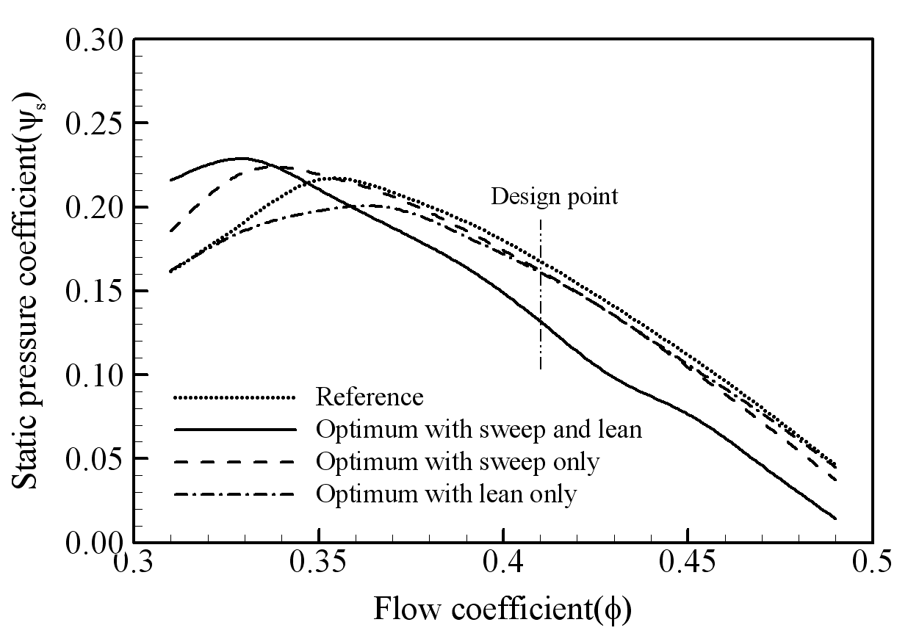
Figure 1. The caption heading for a figure should be placed below the figure and within figure/illustration width. (Use “Arial” font, size 10pt, no spacing between title and figure)
(1 line spacing here)
  - Footnotes
Footnotes are not allowed.
(1 line spacing here)
  - Units
Use either SI (MKS) as primary units. English or CGS units may be used as secondary units (in parentheses). Avoid combining SI and CGS units. This often leads to confusion because equations do not balance dimensionally. If you must use mixed units, clearly state the units for each quantity that you use in an equation. Do not mix complete spellings and abbreviations of units. Spell out units when they appear in text.
(2 lines spacing here)

- CONCLUSIONS
If the formatter still needs to create a component which is not prescribed here, please incorporate applicable criteria that follow the styles provided (e.g., spacing and typeface).
(1 line spacing here)
ACKNOWLEDGEMENTS (Use “Arial” font, uppercase, bold, size 10 pt)
This is where one acknowledges funding bodies, etc. Note that section numbers are not required for Acknowledgements and References.
We appreciate the cooperation and efforts of all authors in producing the Proceedings. This will be a great congress following the tradition of our sponsoring organizations.
(1 line spacing here)
REFERENCES (Use “Arial” font, uppercase, bold, size 10 pt)
References should appear together at the end of the extended abstract, listed alphabetically by last name of the first author. Please use Harvard APA 6 or 7 citation standard. Here are some examples:

Dong, N.C. (note: no spacing between initials), Araki, H., Yamanishi, H., and Koga, K. (2005). Simulation of groundwater flow and environmental effects resulting from pumping. Environmental Geology, 47 (3), 361-374.
Donelan, M.A. (1978). Whitecaps and momentum transfer. NATO Conf. on Turbulent fluxes through the sea surface, wave dynamics, and prediction, Ed. A. Favre and K. Hasselmann, Plenum, NY, 273-287.
Gran, S. (1992). A course in ocean engineering. Elsevier, 583 pp.
Hwang, P.A., Hsu, Y.H.L. and Wu, J. (1990). Air bubbles produced by breaking wind waves: a laboratory study. J. Phys. Oceanography, 20, 19-28.

12 RULES TO ENSURE YOUR PAPER FOLLOWS THE FORMAT

- Read this guide carefully and then, build your paper on it.
- Upload your abstract in PDF format, and keep the Word version, it might be requested by IAHR in other to produce the proceedings.
- Do not insert page or section breaks.
- Do not modify the setting of the template (margins, spaces, or sizes).
- Any paper which format is different from the template's setting will be rejected.
- Do not insert any table of contents.
- Please, insert any graphics in picture format.
- Do not use macros or hyperlinks.
- Do not numerate pages and/or lines in the final document.
- Do not use Word’s review mode in the final document.
- Do not modify the header or footer.
- Do not hesitate to contact us for help!

