Insert your extended abstract title here
Name Surname ¹, Name Surname ² and Name Surname ³
^{1,3} Affiliation Institution 1, City, Country,
e-mail
² Affiliation Institution 2, City, Country,
e-mail (
ABSTRACT

This document presents the instructions needed to prepare the 2 page- extended abstract (850-1000 words) in length including figures and references). The various components of your extended abstract [title, text, heads, etc.] are already defined on the style sheet, as illustrated by the portions given in this document. A concise abstract is required. The abstract (in one paragraph of 150 words or less) should state briefly the purpose of the research, the essential new information, the principal results and major conclusions. The abstract must be able to stand-alone and references to the manuscript should therefore be avoided. Extended Abstracts must be written in English. Pages and/or lines must not be numbered.

Keywords: please list a maximum of 5 keywords separated by semicolons and full stop at the end.

- INTRODUCTION

Please follow the format described here and demonstrated by example with regard to placement of extended abstract title, length and width of text. These instructions serve as an example for proper manuscript production. The figures can be in color since the extended abstract is published online.
The authors of the accepted abstracts must submit the extended abstract before the deadline through the congress website. Please keep your word version in case it is requested.

[1]

[2]

 | A | B | C | D
A | Aa | Ab | Ac | Ad
B | Ba | Bb | Bc | Bd
C | Ca | Cb | Cc | Cd
D | Da | Db | Dc | Dd
E | Ea | Eb | Ec | Ed
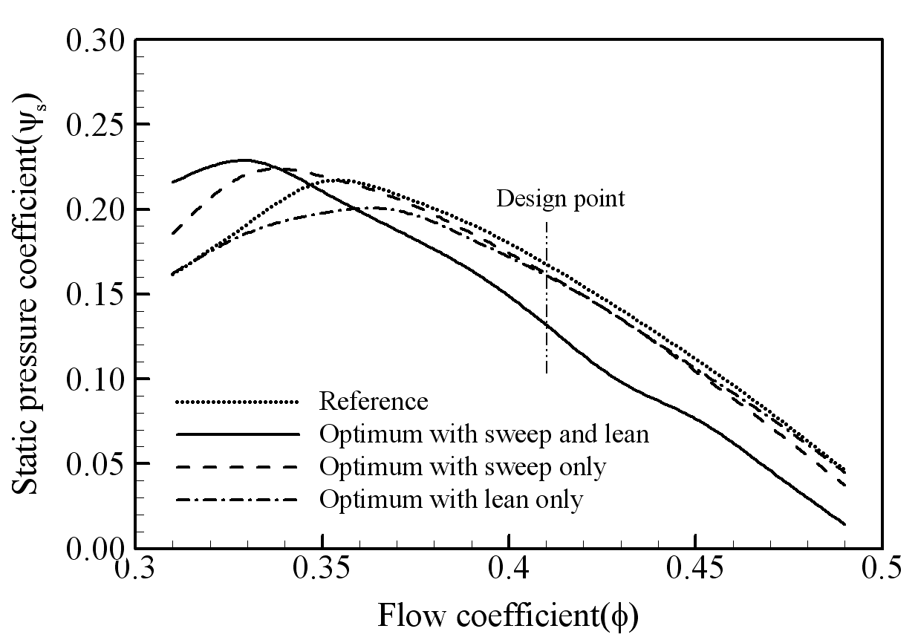

- ANY OTHER POINT YOU WISH TO ADD
- CONCLUSIONS
If the formatter still needs to create a component which is not prescribed here, please incorporate applicable criteria that follow the styles provided (e.g., spacing and typeface).
REFERENCES
References should appear together at the end of the extended abstract, listed alphabetically by last name of the first author. Please use Harvard APA 6 or 7 citation standard.

Dong, N.C.,Araki, H., Yamanishi, H., and Koga, K. (2005). Simulation of groundwater flow and environmental effects resulting from pumping. Environmental Geology, 47 (3), 361-374.
Donelan, M.A. (1978). Whitecaps and momentum transfer. NATO Conf. on Turbulent fluxes through the sea surface, wave dynamics, and prediction, Ed. A. Favre and K. Hasselmann, Plenum, NY, 273-287.
Gran, S. (1992). A course in ocean engineering. Elsevier, 583 pp.
Hwang, P.A., Hsu, Y.H.L. and Wu, J. (1990). Air bubbles produced by breaking wind waves: a laboratory study. J. Phys. Oceanography, 20, 19-28.

12 RULES TO ENSURE YOUR PAPER FOLLOWS THE FORMAT

- Read this guide carefully and then, build your paper on it.
- Upload your abstract in PDF format, and keep the Word version, it might be requested by IAHR in other to produce the proceedings.
- Do not insert page or section breaks.
- Do not modify the setting of the template (margins, spaces, or sizes).
- Any paper which format is different from the template's setting will be rejected.
- Do not insert any table of contents.
- Please, insert any graphics in picture format.
- Do not use macros or hyperlinks.
- Do not numerate pages and/or lines in the final document.
- Do not use Word’s review mode in the final document.
- Do not modify the header or footer.
- Do not hesitate to contact us for help!

